**Lesson 9 Demo 9**

**AKS Monitoring and Logs**



**Steps to be followed:**

1. Monitoring cluster health using Azure Monitor
2. Checking logs of a running pod using Azure Log Analytics
3. Checking logs of a running pod using Azure Cloud Shell

**Step 1: Monitoring cluster health using Azure Monitor**

1. On Azure portal home page search for **Monitor** and select the **Monitor** service under **Services** section:

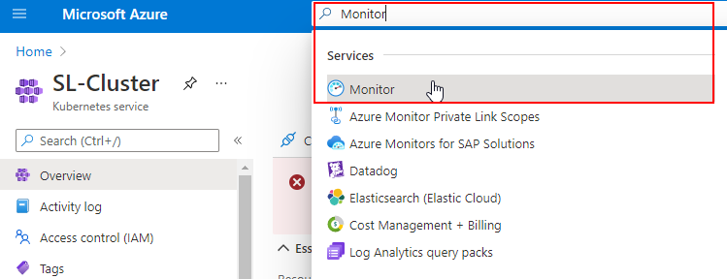

1. On the Monitor service page, navigate to **Containers** under **Insights** and click on **SL-Cluster** under **Monitored clusters** tab:

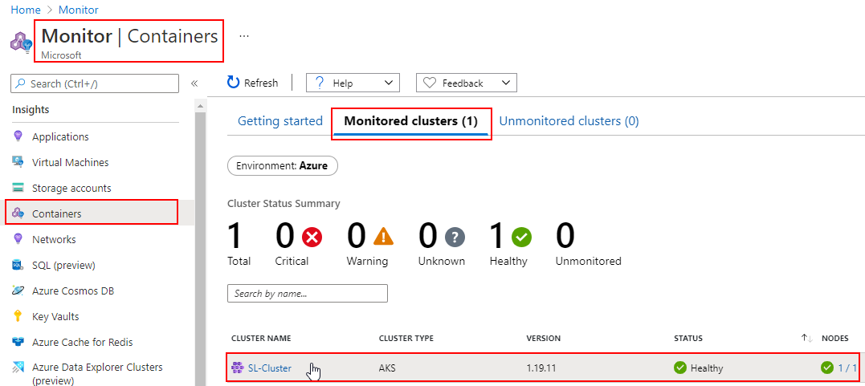

1. On the SL-Cluster | Insights page, check the cluster health through various graphs such as **Note CPU utilization %, Node memory utilization %, Node count,** and **Active Pod count:**

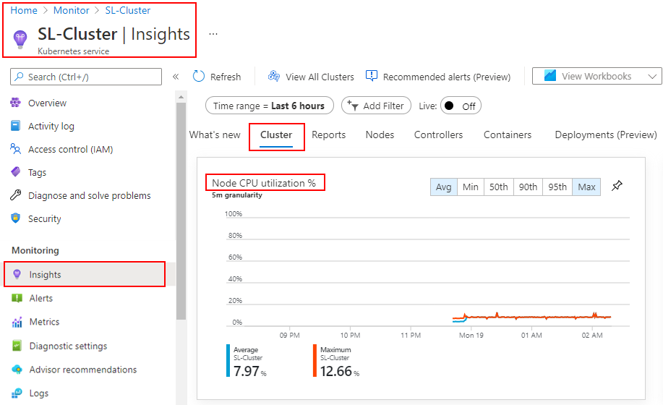

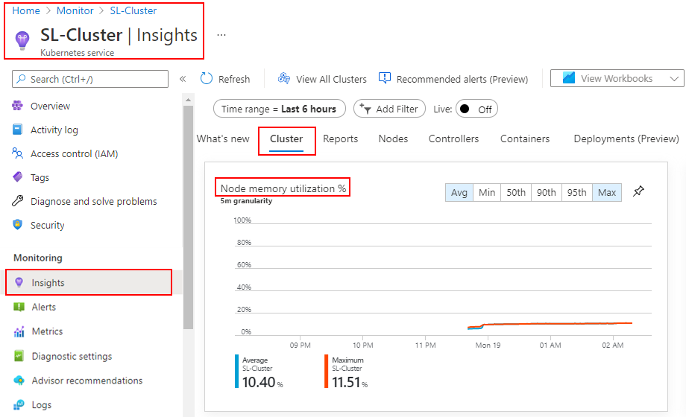

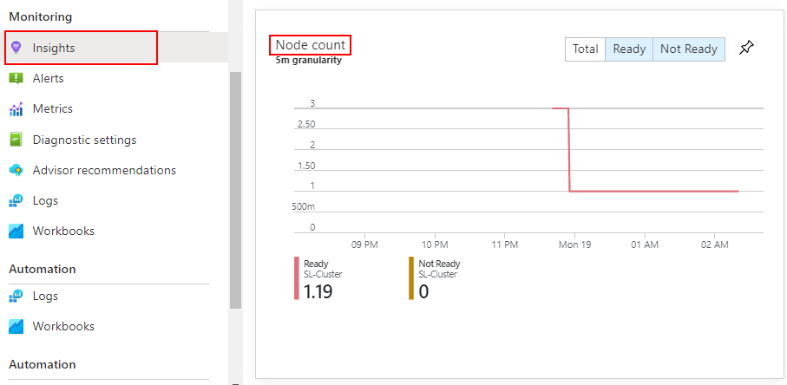

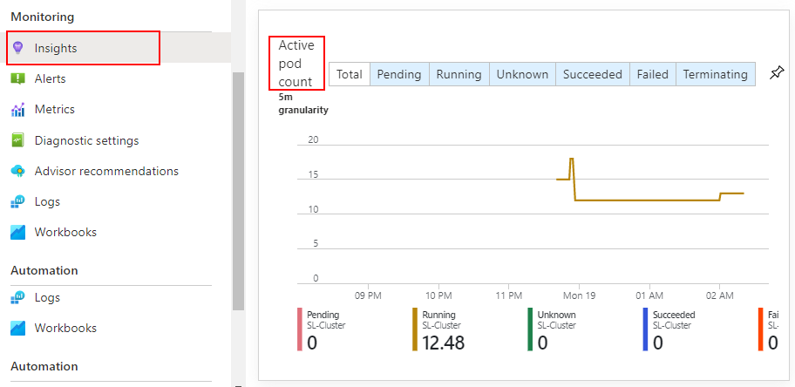

**Step 2: Checking logs of a running pod using Azure Log Analytics**

1. In SL-Cluster, navigate to the **Workloads** and click on any pod (in this case, we have opened **pv-pod**) under the **Pods** tab:

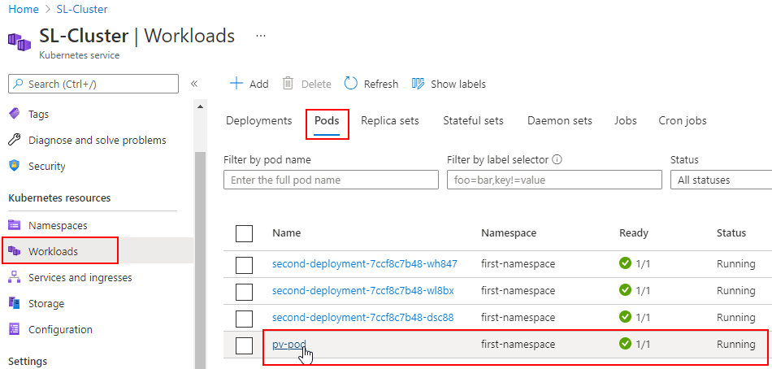

1. Inside the Pod, click on **Live Logs** to check live logs for the running pod:

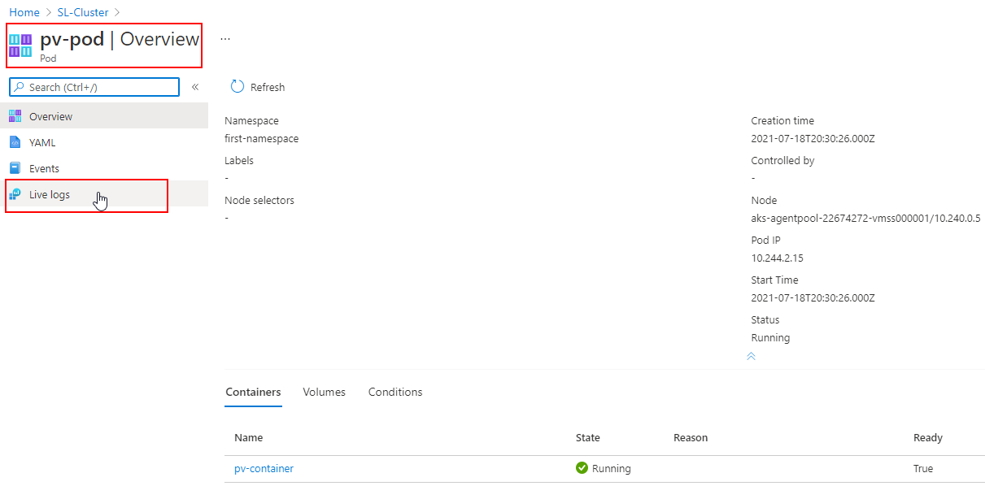

1. On Live Logs page, select the Pod from the dropdown and click on **View in Log Analytics:**

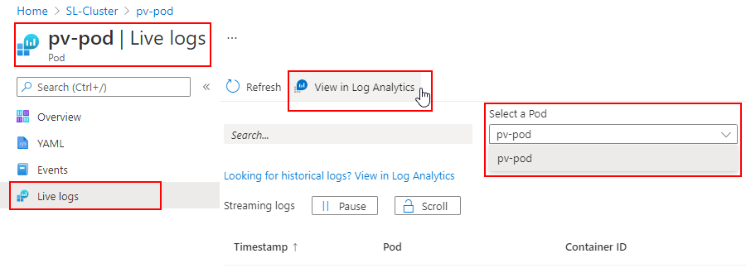

1. Click on the **Run** button to check logs for troubleshooting a Pod:

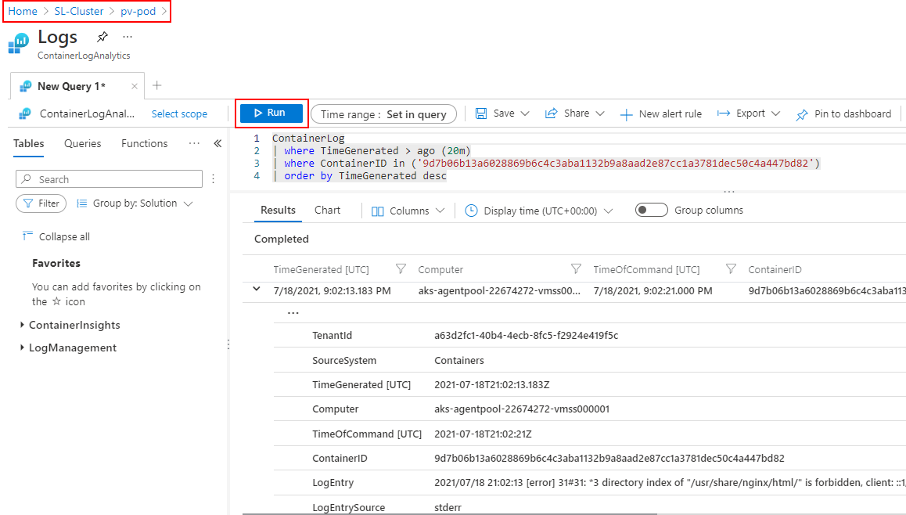

**Step 3: Checking logs of a running Pod using Azure Cloud Shell**

1. Open **Azure Cloud Shell** and connect the SL-Cluster with **BASH:**

| **Note:** Follow **Step 3.6** to **3.8** of **Lesson 8 Demo 3** to establish the connection. |
| --- |

1. Run the following command to check logs for a running Pod:

***kubectl logs pv-pod -n first-namespace --tail=100***

